**Appium Setup Procedure**

Please find the below given steps, which will guide you to **install appium on windows machine**.

Before downloading and installing appium in windows, please make sure below given prerequisites are fulfilled.

1. JDK Installed.
2. Android Studio Installed
3. Environment Variables Path Created

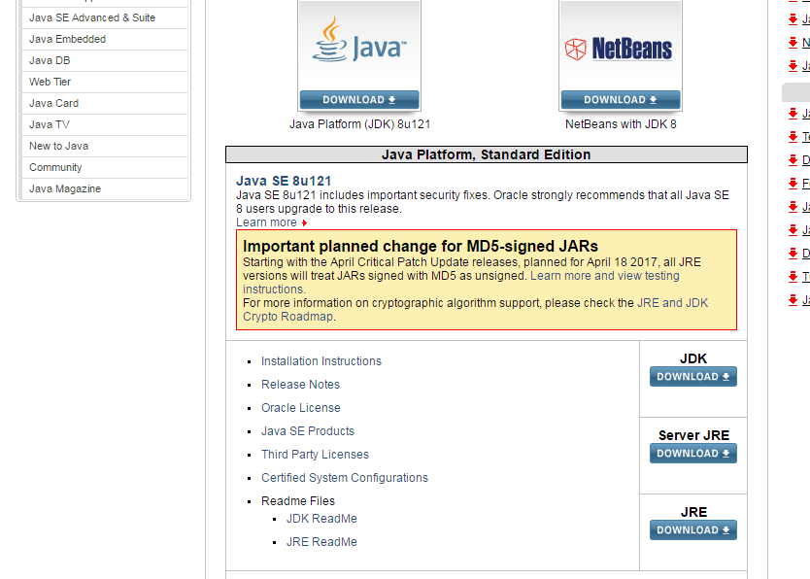

Go to <http://www.oracle.com/technetwork/java/javase/downloads/index-jsp-138363.html> .

* Click on JDK file download option
* Click Install button

The JDK file will be automatically saved in the following Path“ C:\Program Files\Java”

1. Android Studio  :

Below are the system requirements that are necessary to Install Android SDK.

* 2 GB RAM minimum, 4 GB RAM recommended
* Microsoft® Windows® 8/7/Vista/2003 (32 or 64-bit)
* 20 to 30 GB Hard disk space.

The procedure to download and install Android Studio is as follows:

As the size of Android SDK is approximately 1.5 GB it will take at least half an hour to download and install. It may vary according to net speed.

For downloading android SDK,

* Go to this software web application page -> [**http://developer.android.com/sdk/index.html**](http://developer.android.com/sdk/index.html)
* Scroll down to bottom of page.
* There will be SDK Tools Only" under "Other Download Options" section.
* Click on **android-sdk_r(Version number)-windows.zip** link e.g. **android-sdk_r24.3.3-windows.zip**as shown in bellow image.

[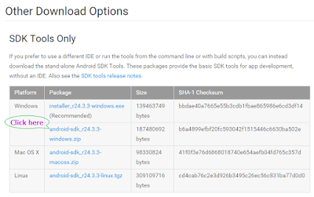](http://4.bp.blogspot.com/-Q8DcoY02guY/Vc1GFQmiaqI/AAAAAAAAB4E/06IxFLhqGzg/s1600/Download%2Bandroid%2Bsdk%2Btools%2Bonly.png)

* It will download android SDK zip file as sown in below image.

[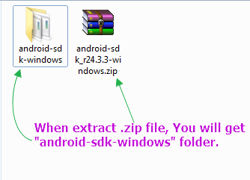](http://4.bp.blogspot.com/-7XZNMU2x9GY/Vc1KOZfo0HI/AAAAAAAAB4Q/SQlQDPSaCq0/s1600/extract%2Bandroid%2Bsdk%2Bfolder.png)

* Place the zip file in the drive. (**Note**: Android SDK needs 20 to 30 GB space on disc to store different files. So select appropriate disc where enough space is available.)
* Extract .zip file. You will get "android-sdk-windows" folder as shown in above image.
* Rename folder name from "**android-sdk-windows**" to "**SDK**" for easy name.

3. Setting Environment Path Variables:

It is necessary to set the path for

* Android sdk
* Java sdk

And attach that path to the system original system path .For that the steps are as follows:

* **Setting Path for Android sdk**

Go to Control panel >> System and Security >> System and from the left panel click on 'Advance System Settings'. From 'System Properties' pop up, click on 'Advance' tab and then click on "Environment Variables" button.

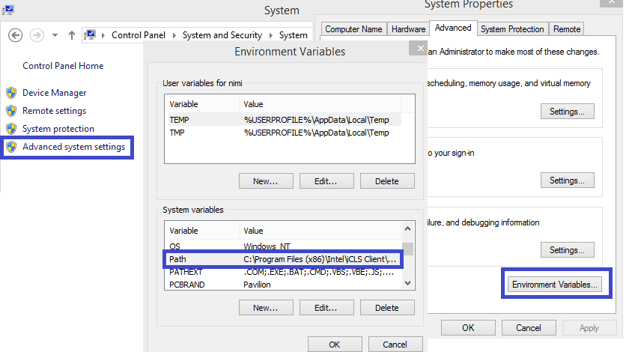

Now go to Android visual studio open Android SDK manager. Go to path and select the SDK path which will be as above in the image i.e. C:\Users\Administrator\AppData\Local\Android\Sdk

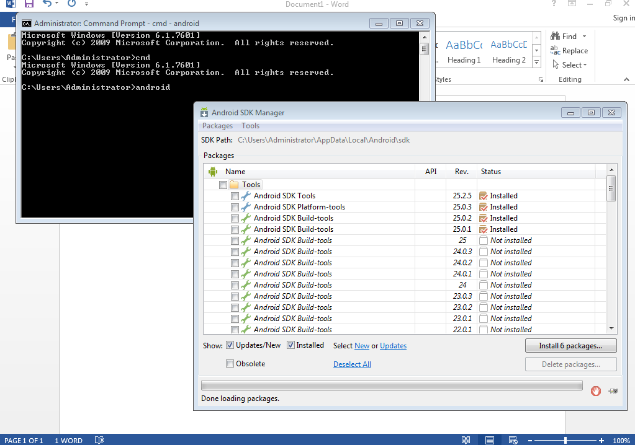

Copy the path and go to Environment variables Window the as show in the image.

Create new System Variable called “Android_ Home” and give the above path you got from android sdk manager to it.

* **Setting Path for Java sdk**

For Java Sdk copy JDK’s path from the system and create a new system variable called JAVA_HOME. And save it.



The next step is to give extension to the “Path” variable so that we can attach both Andoid_Home and Java_Home to the system Path.

For that in the editor add the value ‘***;C:Program Files\ Files\Java\jdk1.8.0_45\bin or*** ‘;%JAVA_HOME%\bin‘ ‘ to the path variable at the end.

Now for Android it will be ‘**;%ANDROID_HOME%\tools**‘

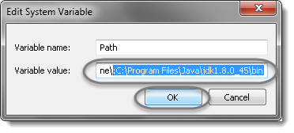

Now we need to verify that if Java Sdk is properly connected to system or not. For that go to ***Start*** and type ***cmd***in the ***Run*** and hit ***Enter***. It will launch the *Command Prompt*. Type ‘***java -version***‘, command and it will display the following information.

Or type ‘***javac***‘ it will return the following Java Information:



|  |  |
| --- | --- |
| 1  2  3  4  5  6  7  8  9 | C:\Users\ >javac  Usage: javac <options> <source files>  where possible options include:    -g                         Generate all debugging info    -g:none                    Generate no debugging info    -g:{lines,vars,source}     Generate only some debugging info    -nowarn                    Generate no warnings    -verbose                   Output messages about what the compiler is doing    -deprecation               Output source locations where depre |

With setting of Environment variables path one part is finished. Now the next step is to install Appium software

It can be done as follows

**Downloading Appium**

Downloading:

For downloading appium in windows,

* Go to https://appium.io/downloads.html
* Click on Download Appium button.

[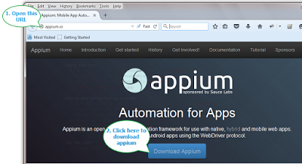](http://1.bp.blogspot.com/-L_FG8BxHKxk/Vc__2D9l2dI/AAAAAAAAB7w/I3rSRom-wkU/s1600/download%2Bappium%2Binstaller.png)

* It will download zip file.
* When download completes, Extract zip file. You will get Appium for Windows folder as shown below.

[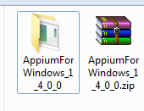](http://1.bp.blogspot.com/-s6M4pwxASaY/VdADYLmcACI/AAAAAAAAB8E/QKaJkOutRro/s1600/appium%2Binstallation%2Bfolder.png)

**b)Install Appium**

* Open Appium for Windows folder. "appium-installer.exe" file will be there.
* Double click on "appium-installer.exe" file to install appium. It will start installing appium.
* It will ask you to select setup language.
* Select English and click on **OK**.

[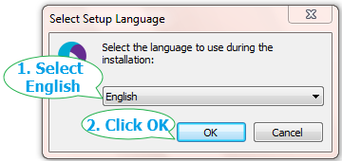](http://1.bp.blogspot.com/-XnJARMxbuHU/VdAEMdB9RYI/AAAAAAAAB8M/MFOFsj-II5A/s1600/1-%2Bselect%2Bappium%2Blanguage.png)

* It will launch Appium Setup Wizard. Click on **Next**button.

[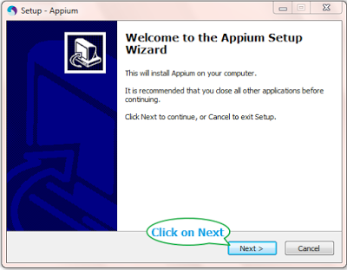](http://4.bp.blogspot.com/-7gRgCB56raY/VdAE8Ijyi3I/AAAAAAAAB8Y/YDhcJgxTWX0/s1600/2-%2Bappium%2Bsetup%2Bwizard.png)

* Next screen will ask you to select appium destination location. Leave it as it is and click on **Next**.

[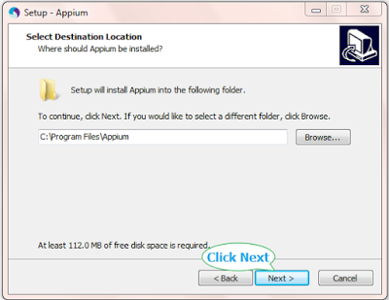](http://3.bp.blogspot.com/-jUrkfkw1ORo/VdAFZjNsEhI/AAAAAAAAB8g/6rn7sAChhrc/s1600/3-%2Bselect%2Bappium%2Binstallation%2Bpath.png)

* Next screen will ask you to set name of appium. Leave it as it is and click on **Next**.

[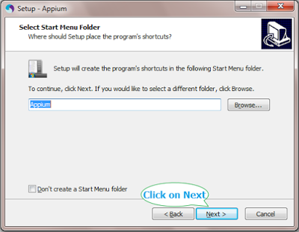](http://4.bp.blogspot.com/-7LfDLBQpjrw/VdAHihBkGiI/AAAAAAAAB8s/lDT-98_V-Pw/s1600/4%2B-%2Bset%2Bappium%2Bstart%2Bmenu%2Bfolder.png)

* Click **Next**on Select Additional Tasks screen.

[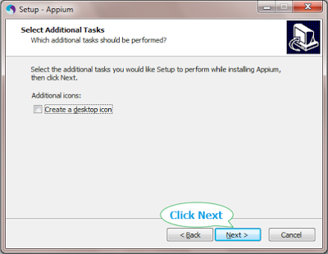](http://1.bp.blogspot.com/-FkcG4F6cv3U/VdAIGY6yXsI/AAAAAAAAB80/NBL2I7ww3Zc/s1600/5.%2BSelect%2Bappium%2Badditional%2Btask.png)

* On Ready to Install screen, Click on **Install**button. It will start installation.

[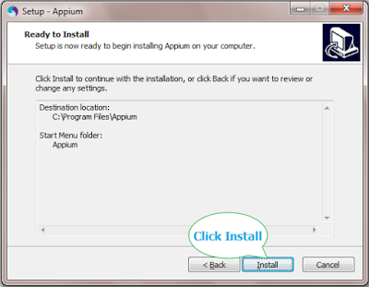](http://4.bp.blogspot.com/-zBv1U9SvWng/VdAIluwLr5I/AAAAAAAAB88/Y62Q-ow2Swo/s1600/6%2B-%2Binstall%2Bappium%2Bin%2Bwindows.png)

* At the end of installation, It will show Completing the Appium Setup Wizard. Select **Launch Appium** check box and click on **Finish**button.

[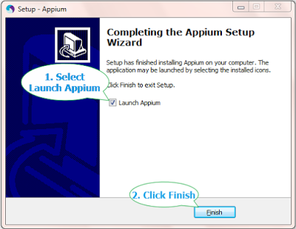](http://1.bp.blogspot.com/-bgTCS80KJb0/VdAKA8o1ExI/AAAAAAAAB9I/VWTmrNhNIqI/s1600/7%2B-%2Bfinish%2Bappium%2Bsetup.png)

* It will launch Appium as shown below.

[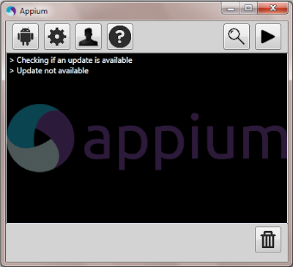](http://4.bp.blogspot.com/-lkbj3hDTYt0/VdAKT22uBiI/AAAAAAAAB9Q/Hz9mjegQ0-g/s1600/8%2B-%2Bstart%2Bappium.png)

**3) Creating Emulator Device from Android SDK**

Creating Emulator device is important if there is no physical device available to connect to the system to automate.

For that the steps are:

->Open Android Studio

->Click on tools

-> Select AVD Manager

->A new Window with the list of devices and their configuration will be displayed

-> Select a device as per your requirement of OS and API level

-> Rename the device name as per your requirement

Below images can be seen for reference to know the way to configure the emulator device.

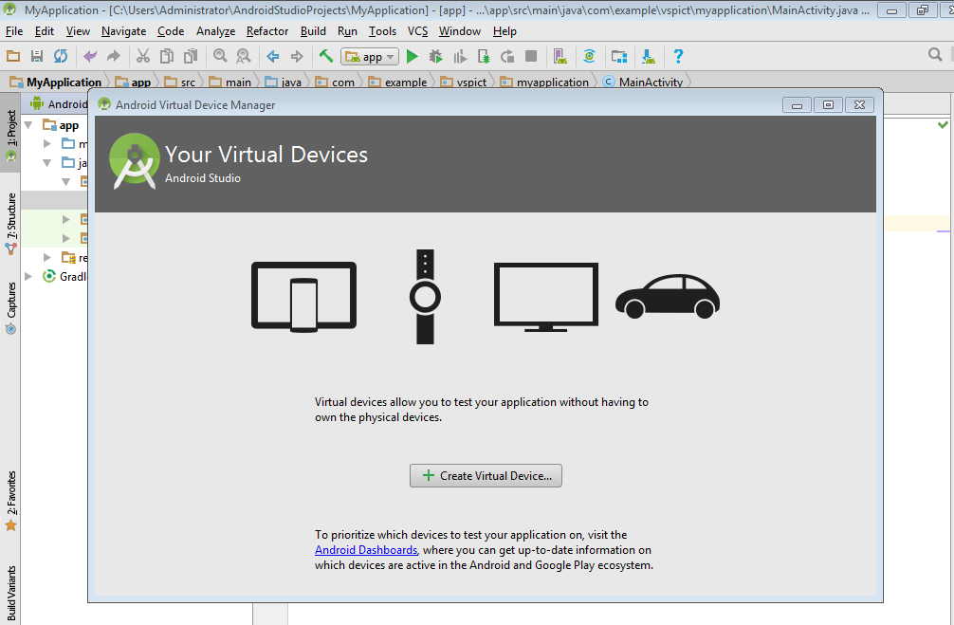

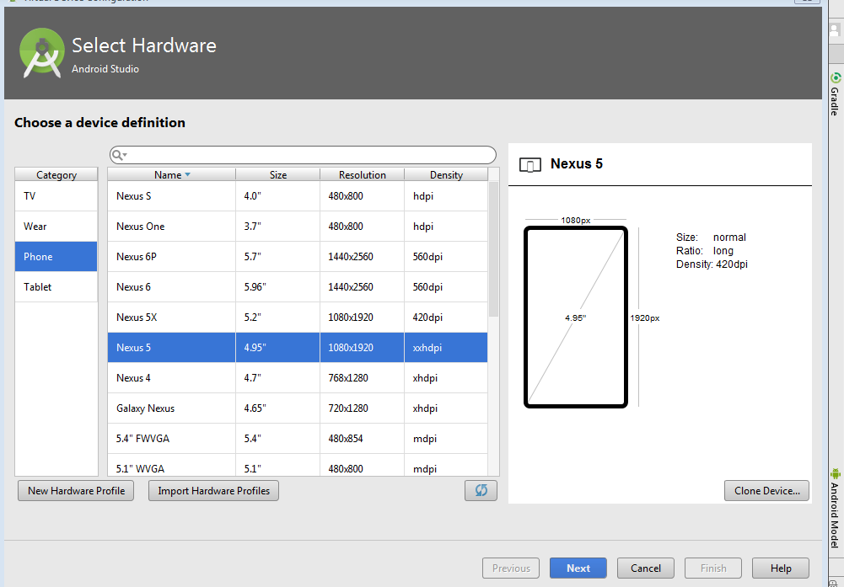

After opening the device it’s imperative to see if the device is running or not.

For that open command Prompt -> click adb devices then it should show the connected devices.

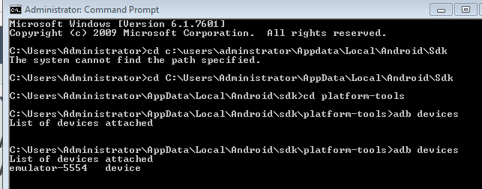

If multiple devices are connected then command prompt will show all the connected devices.

**4) Using UI automator to capture properties:**

To perform operation on app it is important to capture it’s properties for which UIAutomator will be helpful.

Open command prompt and click cd UIAutomatorviewer

Then it will open the automator viewer with which we can capture the properties from node details.

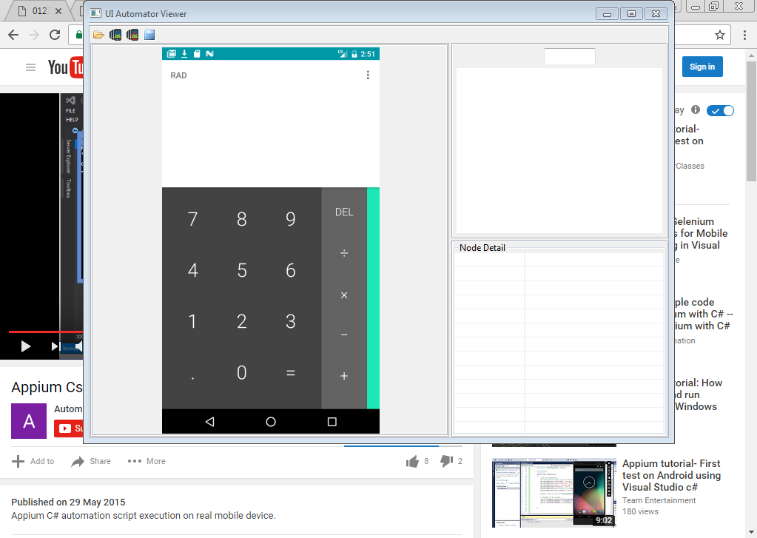

With all requirements finished now the system is ready to automate test using Appium in Visual Studio with c#.

5) Running your first program in Appium with C#:

* Open Visual studio and create new project
* Add following nugget packages. They are
  + - Selenium Web driver
    - Json Nugget Package
    - Appium web driver in visual studio
    - Nunit Package
    - .Net webdriver
  + **Selenium Web driver**

Go to the URL :https://www.nuget.org/packages/Selenium.WebDriver/

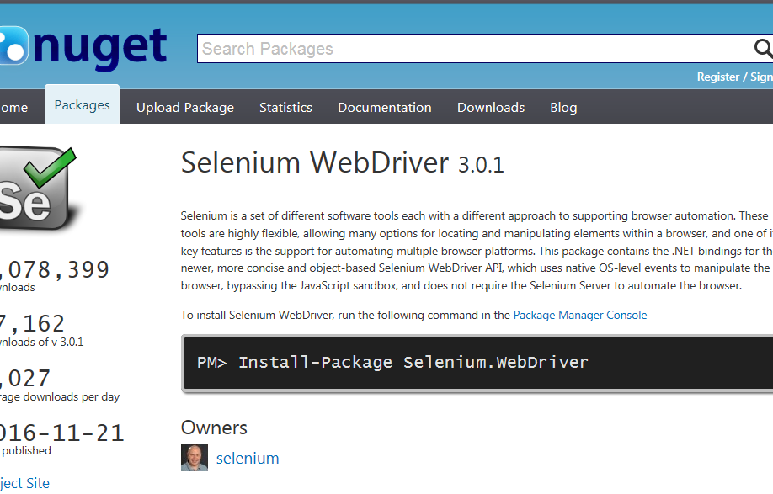

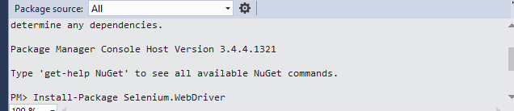

Copy the package Code i.e. PM> Install-Package Selenium.WebDriver

Open Visual Studio-> Create a Test Project ->Click on Tools -> Go to Nugget Package Manager-> Click Package Manager console.

Paste the above code in the package manager console and press enter.

The system will automatically install the driver or the other way is to

Open Visual Studio->Create Test Project ->Click on Tools -> Go to Nugget Package Manager-> Manage Nugget packages.

In the browse option click Selenium WebDriver and then install it into current project

* **Installing Json and Nunit Nugget Packages**

Open Visual Studio->Open the previously created test project ->Click on Tools -> Go to Nugget Package Manager-> Manage Nugget packages.

In the browse option click Nunit, Json Nugget packages then install it into current project.

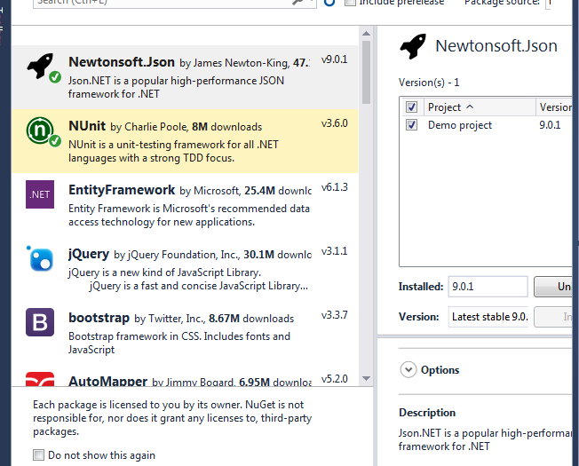

**Installing Appium Webdriverin Visual Studio:**

* Open Visual Studio->Create Test Project ->Click on Tools -> Go to Nugget Package Manager-> Manage Nugget packages.
* In the browse option click Appium webdriverNugget packages then install it into current project.

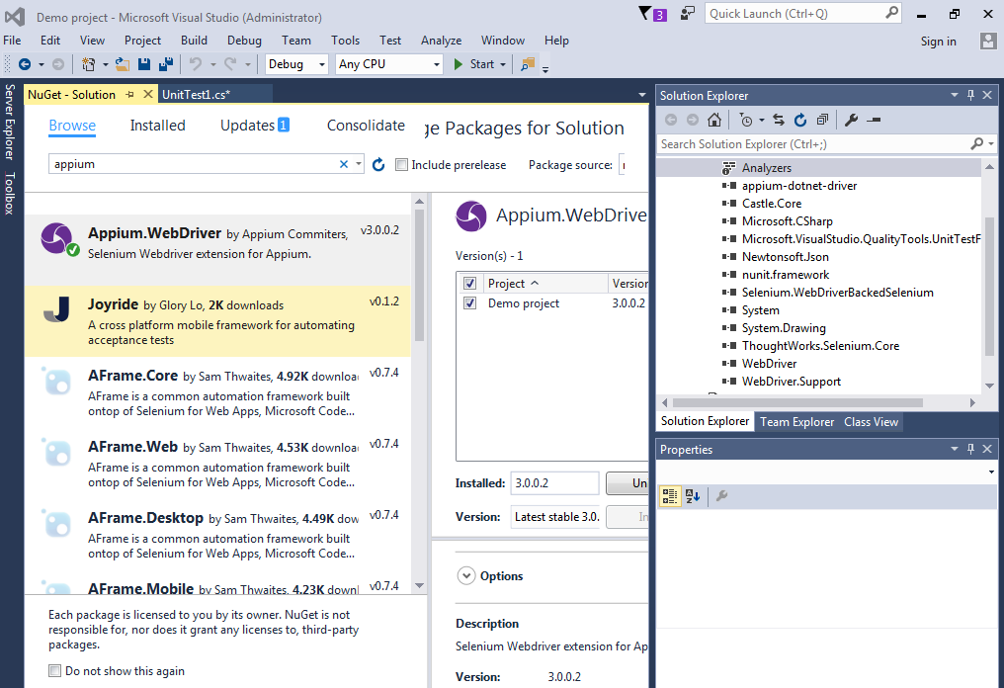

**. Adding .Net Nugget Package:**

* Go to the below link and download .Net Nugget package
* <https://www.microsoft.com/en-in/download/confirmation.aspx?id=17851>
* Open Visual Studio -> Go to solution explorer -> Right click on reference -> Select Add references -> Browse .Net 4.0 File and click it.

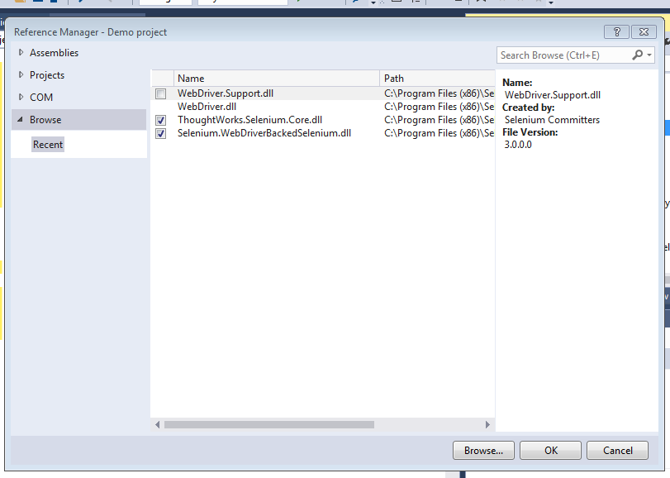

Now the solution explorer tab will look like this as below:

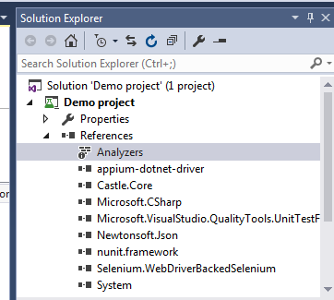

* Open Visual studio with the created project that have the list of nugget packages added to it.
* Enter the code in the Visual Studio
* Start the Appium server
* Open the android device that you have created and added to the code
* Run the program to check the desire operation

For reference this document contains calculator code which we have used to interact with the device.

Please check the below code:

using System;

using System.Collections.Generic;

using System.Linq;

using System.Text;

using System.Threading.Tasks;

using OpenQA.Selenium;

using OpenQA.Selenium.Support.UI;

using System.Threading;

using OpenQA.Selenium.Remote;

using OpenQA.Selenium.Appium;

using OpenQA.Selenium.Appium.Android;

using Microsoft.VisualStudio.TestTools.UnitTesting;

namespace demotest

{

[TestClass]

public class cal

{

AppiumDriver<IWebElement> driver;

[TestMethod]

public void methodcal()

{

Console.WriteLine("Hello");

AppiumDriver<IWebElement> driver;

//AppiumDriver driver;

DesiredCapabilities cap = new DesiredCapabilities();

cap.SetCapability("deviceName", "demo");

cap.SetCapability("platformName", "Android");

cap.SetCapability("platformVersion", "7.0");

cap.SetCapability("appPackage", "com.android.launcher3 ");

cap.SetCapability("appPackage", "com.android.launcher3 ");

cap.SetCapability("appPackage", "com.android.calculator2");

cap.SetCapability("appActivity", "com.android.calculator2.Calculator");

driver = new AndroidDriver<IWebElement>(new Uri("http://127.0.0.1:4723/wd/hub"), cap);

driver.FindElement(By.Name("7")).Click();

driver.FindElement(By.Name("+")).Click();

driver.FindElement(By.Name("5")).Click();

driver.FindElement(By.Name("=")).Click();

IWebElement a = driver.FindElement(By.Id("com.android.calculator2:id/formula"));

if (a.Text.Equals("13"))

{

Console.WriteLine("Text Present");

}

else

{

Console.WriteLine("Text not Present");

}

Thread.Sleep(7000);

driver.Quit();

}

}

}